

JAMES ANDREWS

James Andrews is the managing partner/co-founder of Everywhere specializing in the creation of digital strategies, online communications, and web content production. Everywhere is a strategic communications agency that focuses in helping brands and individuals navigate the social media and online space to build better connections with their audiences. Their clients include Delta, CNN, Macy’s, PGI, Promethean, Georgia Public Broadcasting, Actress/Author/Activist Jane Fonda, and Music Producer Jermaine Dupri. Everywhere is a Guinness World Record holder for the most widespread social media message within 24 hrs for #BEATCANCER (www.beatCancerEverywhere.com)

Before launching Everywhere, Andrews was Vice President, Ketchum Digital and directed global social media brand strategies for Monster.com, FedEx, GeekSquad, Nokia, Wendy’s and Newell Rubbermaid. As an internationally respected digital thought leader, Andrews helped start a Social Media practice in the Ketchum Brazil office and has been a keynote speaker in Sao Paulo, London and Norway. Andrews has been working in the area of interactive/new media and non-traditional marketing for 15 years holding senior titles at Urban Box Office, Columbia Records, Ecko Unlimited and Isobar/Carat. His experience with brands such as Current TV, Coca-Cola/Sprite, Truth.com and Proctor & Gamble places him in a unique category of entrepreneurs that understand the convergence of new media, content, social activism and digital lifestyle.

James blogs at Fastcompany.com as an Expert Blogger as well as Huffington Post. Andrews can be seen as a regular contributor on CNN Weekend discussing current news and social media stories.

James Andrews attended UCLA, grew up in Silicon Valley, and lives in Atlanta with his wife and two children. His community involvement includes volunteer work at GCAPP, The Paideia School and Morehouse College.

DIGITAL REAL ESTATE


www.twitter.com/keyinfluencer

LIFESTREAM
www.jamesandrews.tv

Blog
www.thekeyinfluencer.com

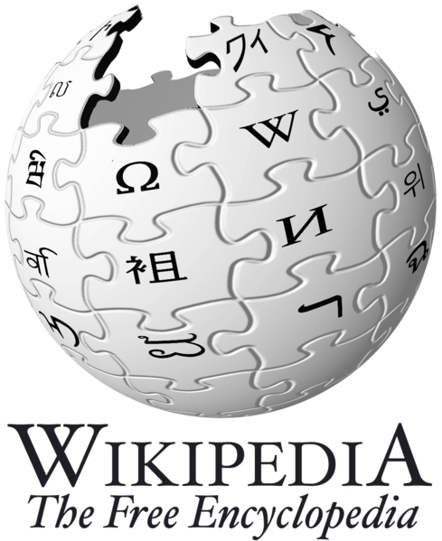

http://bit.ly/VSV5w

 www.facebook.com/jamesandrews



http://www.linkedin.com/in/keyinfluencer



http://www.fastcompany.com/user/james-andrews

