FOR IMMEDIATE RELEASE MAY 10, 2010

COX INTRODUCES ADVANCED TV PLUS PACKAGE- A SUPERIOR
TV EXPERIENCE ENABLED BY NEW TRIO PROGRAM GUIDESM

‘Plus Package’ Offers Advanced Interactive Programming Guide, Whole Home DVR, More DVR Storage, More HD Channels, Zone Channels and Personalization

ATLANTA- Cox Communications today announced its new superior TV experience, the Plus Package, available with Cox Advanced TV, offering access to:
- The Trio program guideSM - A new, advanced interactive programming guide
- Whole Home DVR Service
- Additional DVR storage space
- Additional high-definition channels
- Zone Channels

Plus Package will debut in select Cox markets in the second quarter and will be deployed to Cox’s entire footprint by year-end.

The crown jewel of the Plus Package subscription is access to Cox’s innovative and highly-anticipated Trio program guide, designed by Cox in partnership with Frog Design and implemented by NDS.

“Plus Package gives customers everything they’ve been asking for – more great HD content; easier, more intuitive discovery of programming; the ability to personalize their TV viewing; and, with whole home DVR, anytime/any room access to what they want to watch,” commented Steve Necessary, vice president of video strategy and product management for Cox. “We are especially excited for Cox customers to experience the revolutionary Trio guide, which we built in response to their feedback on how a better guide could improve their TV viewing experience.”

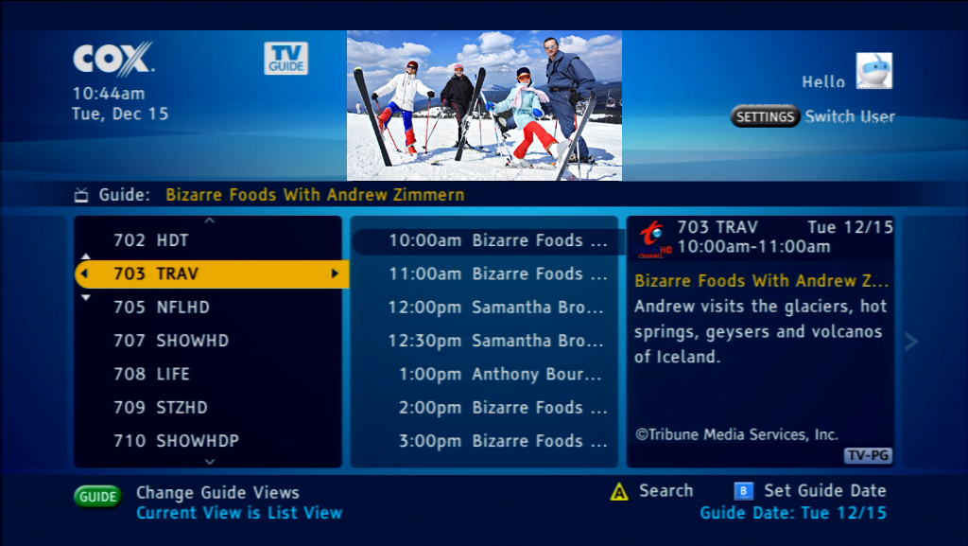
The Trio guide features three panels on a single screen to make content browsing easier, more informative and intuitive. Panel one (left) lists channels vertically in numerical order. Panel two (middle) shows programs on the selected channel, and panel three (right) gives a detailed description of the program selected in the middle pane. On DEMAND listings include titles, poster art and program description information all in the three panes of a single Trio screen, making navigation and selection of On DEMAND content fast and easy. In addition, the Trio guide gives customers the ability to sort available program information in a grid guide view, a theme view, a high-definition programming view, a Zone Channels view and a favorite channels view. Uniquely, the Trio guide also endows customers with the ability to search and browse related content across three platforms – linear airings, On DEMAND titles and DVR recordings – seamlessly and conveniently. The Trio guide’s powerful unified search function allows customers to search based on title, actor/director and keyword. The Trio guide’s browse-related feature identifies shows that have something in common with a currently selected show, such as upcoming episodes, related series, shows within the same genre or shows staring the same actors. Up to eight users in a home can personalize their viewing experience by selecting favorite channels and customizing iTV applications.

“After extensive research and thorough review of available guide options, we determined that the best way to meet customers’ needs was to design our own guide from scratch,” said Lisa Pickelsimer, executive director of video product development. “We involved our customers all along the way in our development process. Customers are frustrated with the limited capabilities of simple grid guides and many have resorted to channel surfing only a small number of favorite channels -- missing out on the joy of discovering exciting, new content included in their TV subscription. The easier, more logical navigation and powerful search and browse capabilities we’re giving customers with the Trio guide will help them get more out of Cox Advanced TV as they uncover new entertainment favorites.”

Necessary observed the significance of the Trio guide’s personalization options, “We are no longer serving the household in simple broadcast fashion. Instead, we are serving each individual in the household. Users will be able to access the programming they personally care about rapidly and will more easily find content of interest that they may not know is available. This is just the start of how we will make our video service more relevant for each member of the family.”

Plus Package also offers customers access to the Cox Whole Home DVR solution, allowing them to watch and control recorded shows on any TV in the home from a single DVR unit. Up to three different recordings can be viewed simultaneously on different televisions throughout the home. Customers will also have access to up to three times more DVR storage space with a new 500GB hard drive.

Cox is using tru2way-based Cisco 8642 HD/DVR and 1642 HD receivers to deploy Plus Package and these will be used in all Cox markets, including Cox’s Motorola environments. This marks the first time that a cable company broadly implements a cross platform set-top solution. The new Cisco set-tops also have the capability to tune above 860 Mhz, where Cox will transmit the additional HD channels included with Plus Package in markets so enabled. A leader in the enhancement of its video network for additional capacity, Cox is among the first cable operators to begin delivering video in 860 Mhz spectrum.

“Tru2way has created an environment for innovation,” said James Kelso, Cox’s vice president of video engineering. “Now that we are using a standards-based platform, the opportunity for working with more and different vendors is real. With tru2way, we anticipate faster application development and speedier deployments of new services to our customers.”

Customers can add the Plus Package to any level of Cox Advanced TV (digital video service) for a small monthly fee.
About Cox Communications:
Cox Communications is a broadband communications and entertainment company, providing advanced digital video, Internet, telephone and wireless services over its own nationwide IP network. The third-largest U.S. cable TV company, Cox serves 6.2 million residences and businesses. Cox Business is a facilities-based provider of voice, video and data solutions for commercial customers, and Cox Media is a full-service provider of national and local cable spot and new media advertising. Cox is known for its pioneering efforts in cable telephone and commercial services, industry-leading customer care and its outstanding workplaces. For seven years, Cox has been recognized as the top operator for women by Women in Cable Telecommunications; for five years, Cox has ranked among DiversityInc's Top 50 Companies for Diversity, and the company holds a perfect score in the Human Rights Campaign's Corporate Equality Index. More information about Cox Communications, a wholly owned subsidiary of Cox Enterprises, is available at www.cox.com and www.coxmedia.com.

-30-
Contacts:
David Grabert  Cox Communications  404.269.7054 - phone  678.592.6658 - cell | Erin Lambremont  Cox Communications  404.843.5854- phone  770.335.0545 - cell

