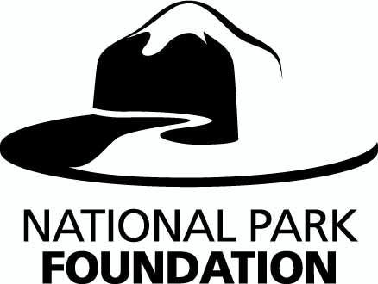
MEDIA CONTACT:
Marjorie Hall, 202.354.6480
mhall@nationalparks.org

FOR IMMEDIATE RELEASE
NATIONAL PARK FOUNDATION UNVEILS NEW PSA CAMPAIGN FOR
THE FLIGHT 93 NATIONAL MEMORIAL

Campaign To Drive $18Million Effort To Build Flight 93 National Memorial
Honoring The Heroes of United Flight 93 and September 11th

Washington, D.C. (August 26, 2010) – The National Park Foundation, the official charity of America’s national parks, today unveiled a new public service campaign reminding all Americans of the heroes of United Flight 93, and encouraging their support in building a national memorial in their honor. On September 11, 2001, the 40 passengers and crew of United Flight 93 heroically fought back against terrorists, and in doing so, saved countless lives and our nation’s capital. In their struggle, they lost their own lives as the plane plummeted into a field outside of Shanksville, PA.

A common field one day, a field of honor forever, the sacred ground of the Flight 93 National Memorial holds great meaning for all Americans. This national memorial, the only one dedicated to the events of 9/11, is an opportunity to honor all the heroes of that tragic day and provide a venue of remembrance, respect, and education for all visitors.

“As we approach the ninth anniversary of September 11th, we are all reminded of the horrific events of that day, and the heroic people that saved countless others and shaped history,” said Neil Mulholland, President and CEO of the National Park Foundation. “Their story must never be forgotten. The Flight 93 National Memorial will serve as an unwavering reminder of their sacrifice, and a symbol of the American public’s commitment, through their financial, emotional and physical support, to make sure the heroes of 9/11 live on.”

The Flight 93 National Memorial public service campaign consists of a 60sec and 30sec video PSA, audio PSA and print materials. Each invites the public to help support the building of the Flight 93 National Memorial through mobile text donations, “Text MEMORIAL to 90999 to donate $10,” or by contributing online at www.honorflight93.org.

The National Park Foundation has embarked on an ambitious campaign to raise $18milion dollars to complete the memorial. The memorial site is currently under construction with plans
to dedicate the memorial on September 11, 2011 – ten years after United Flight 93’s fateful crash. The Flight 93 National Memorial will be the only national memorial dedicated to the events of 9/11.

About the Flight 93 National Memorial
On September 24, 2002, Congress passed the Flight 93 National Memorial Act. The Act created a new national park unit to commemorate the passengers and crew of Flight 93 who, on September 11, 2001, courageously gave their lives thereby thwarting a planned attack on our nation’s capital. The memorial is outside Shanksville, Pennsylvania, where Flight 93 crashed with the loss of its 40 passengers and crew. For more information about the Flight 93 National Memorial, please visit www.nps.gov/flni. For information on how to support the building of the memorial, go to www.honorflight93.org.

About the National Park Foundation
The National Park Foundation is the official charity of America’s national parks. Chartered by Congress, we work hand in hand with the National Park Service to strengthen and connect all Americans to our parks, so they are protected for present and future generations. It is a legacy that began more than a century ago, when private citizens took action to first establish, then protect and endow our national parks. Today, the National Park Foundation carries on that tradition as the only national charitable partner for America’s national parks. To learn more visit www.nationalparks.org.

# # #

